**Team "Heracles"**

Team members:

**Теодор Чолаков**

**Иван Василев**

**Константин Адаму**

**Огнян Алексиев**

**Любомир Йончев**

Project:   
*CrowdSourcedNews* with *web client*

Class Diagram:

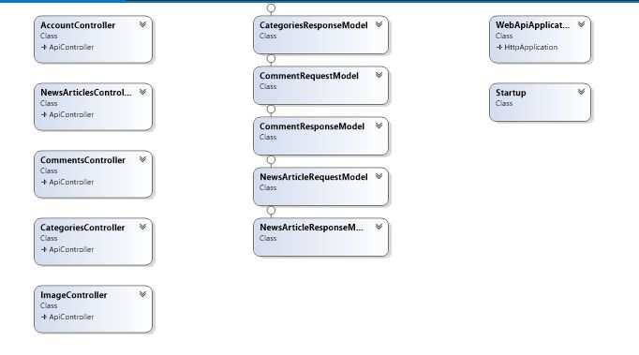

DbDiagram:

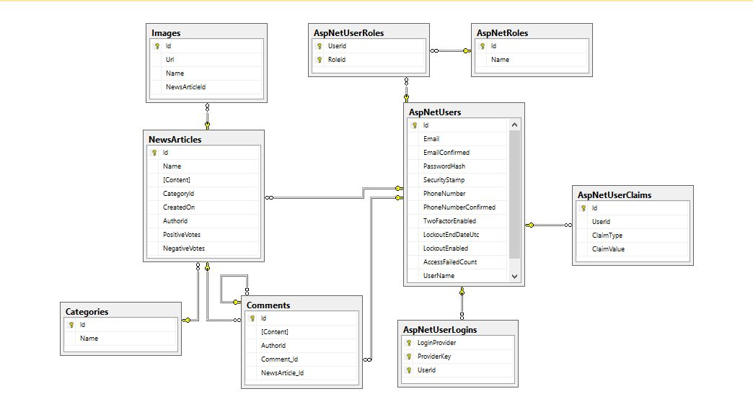

### Project Description

A web application for posting **News Articles**, where one can:

* publish a news article containing images
* add comment under news articles
* comments can be nested
* vote for and against news articles
* receive notifications when a new news article is published

News Articles are stored in different categories.

The URL of our source control repository is:

<https://github.com/Moiraines/WebNews>

Service url in Azure:

<http://crowdsourcednews.azurewebsites.net/>

### Additional Notes

* Server-side: ASP.Net Web API
* Client-side: HTML, CSS, JavaScript (additional libraries and frameworks: Angular, jQuery, Bootstrap, Toastr)